**Bash Lab2**

**Q1: Create a script that asks for user name then send a greeting to him.**



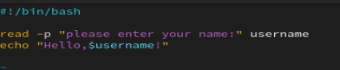

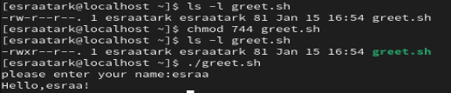

**Q2.Create a script called s1 that calls another script s2 where: a. In s1 there is a variable called x, it’s value 5**

**b. Try to print the value of x in s2 by two different ways.**



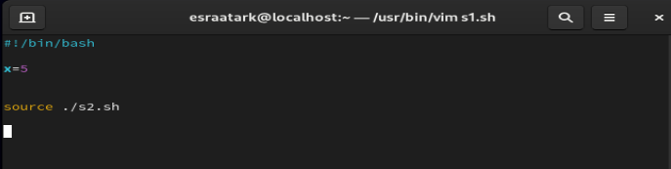



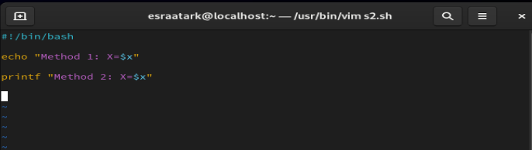





3. Create a script called mycp where:

a. It copies a file to another

b. It copies multiple files to a directory.

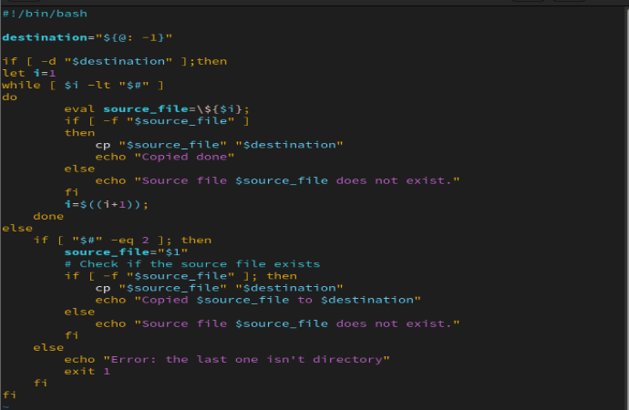

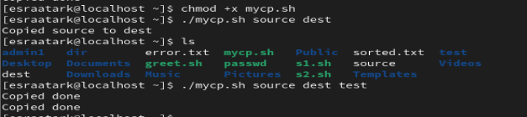

4. Create a script called mycd where:

a. It changed directory to the user home directory, if it is called without arguments.

b. Otherwise, it change directory to the given directory.

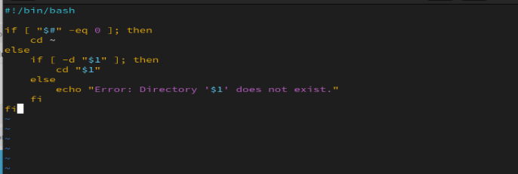



. not ./ because of shell

5. Create a script called myls where:

a. It lists the current directory, if it is called without arguments.

b. Otherwise, it lists the given directory.

